Your course roster provides you with information you need to manage the students enrolled in your class. From the course section roster, you can view the course capacity, enrolled students as well as students on the waitlist.
Use this guide to view your course waitlist.

INSTRUCTIONS
- From the Teaching app, click “View Course Section Roster”.

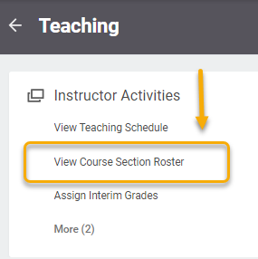
- Select the course in the View Course Section Roster window.

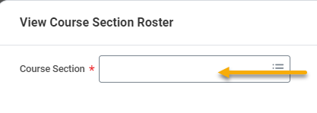
- The next page shows a class roster summary. If there is a waitlist, you will see the Waitlist field with a small arrow to expand details.

